**Ex.No. : 3**

**DML Commands – INSERT, SELECT, UPDATE, DELETE**

1. Populate all the four tables with your own data. 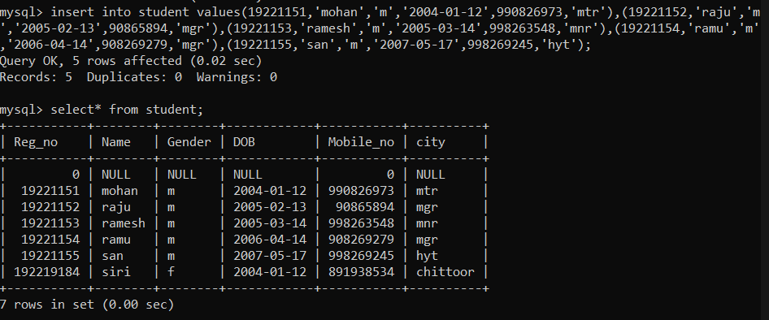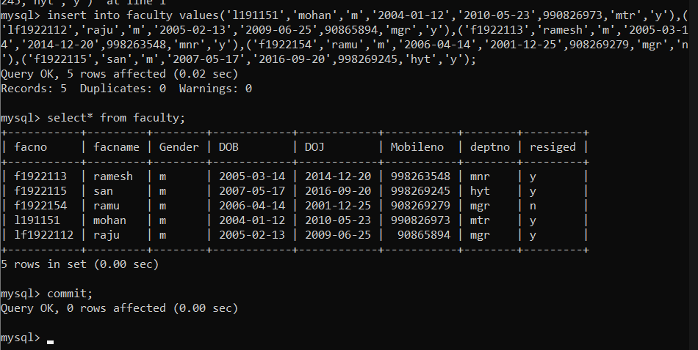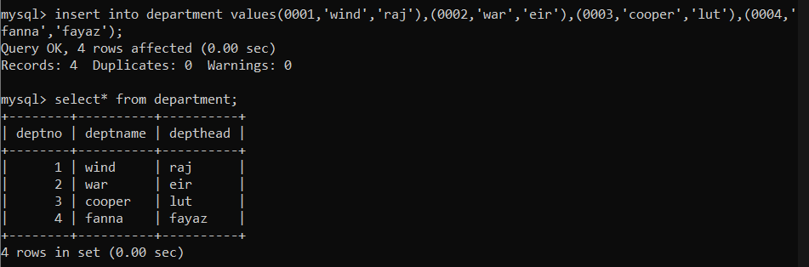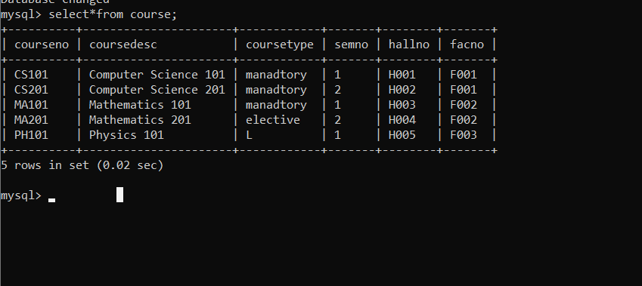
2. Update the value of student name whose register number is ‘191711342’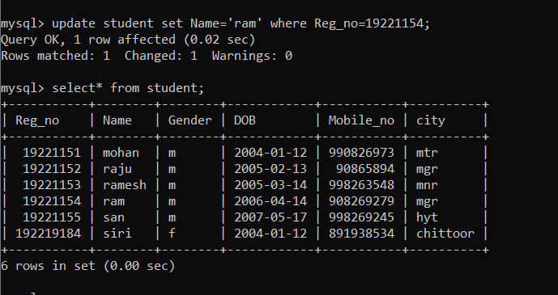
3. Delete the record in the table FACULTY, who resigned her job.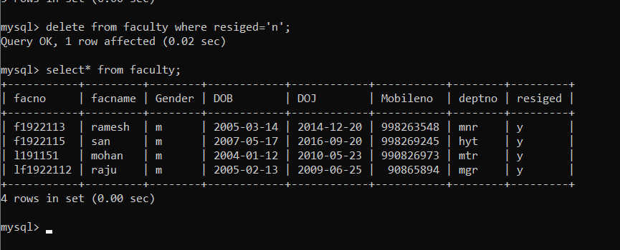
4. Modify the date of birth for the faculty whose name is 'RAM' with a value ‘1983-05-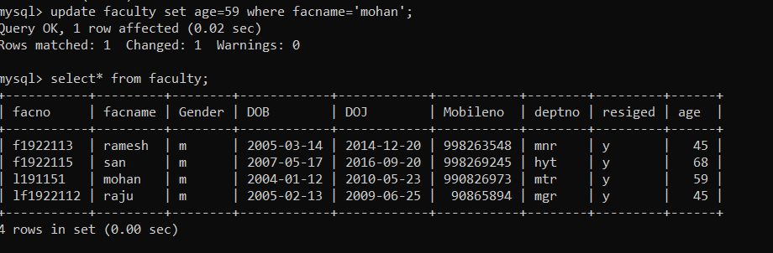01’
5. Remove all faculty who are having over 65 years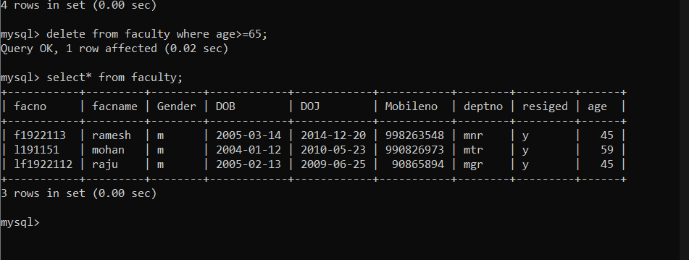
6. View all the records from the five tables. Exercises 